Terms and Conditions

Bozena Zawisz MA will directly provide you with services aligned with the ASD assessment flowchart. The screening instruments used as well as components of this process will vary according to individual circumstances, such as whether an individual attends an educational institution, or what allied health professionals are involved with the individual.
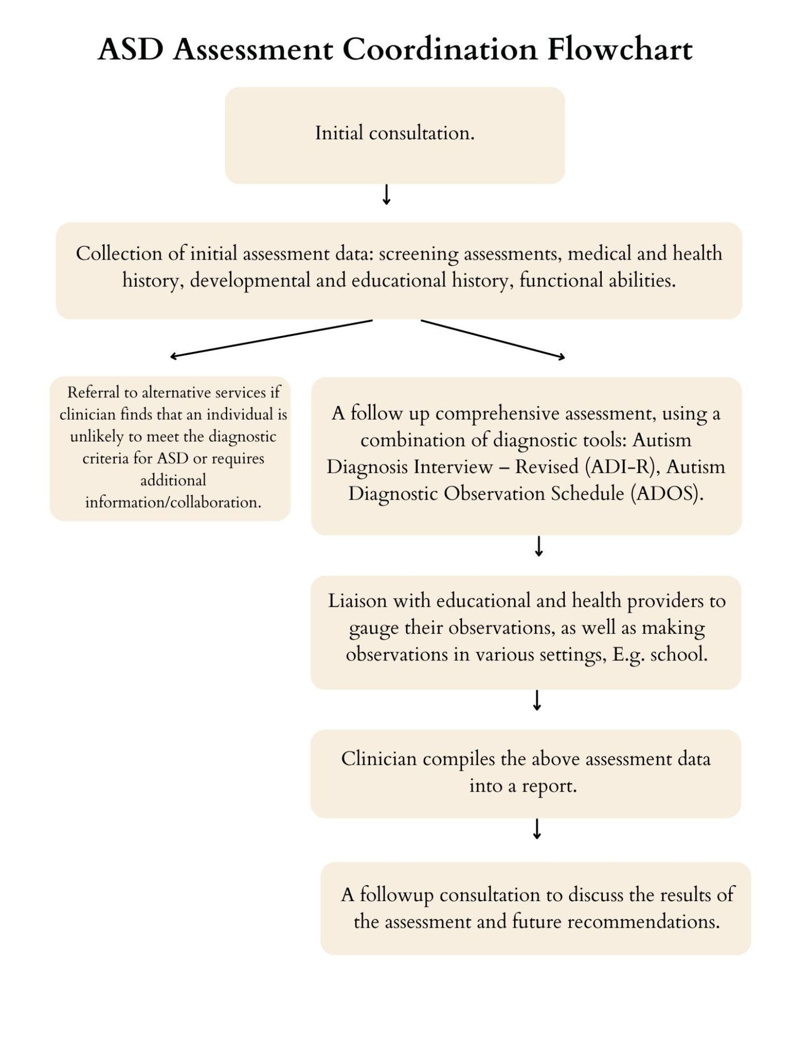

If it is not possible for Bozena to meet your preferences about the way your psychology intervention is legally provided, she will communicate this with you and offer you an alternative.
While Bozena may try to accommodate your requests, there may be times where she must say no to a request, such as when:

Your request is not clinically relevant, reasonable or necessary and does not demonstrate long term benefit for yourself.

Clinician’s responsibilities

Include you in all decisions about the psychology interventions we provide.

Meet with you (in person, online, or over the phone) to follow up on the progress of your intervention.

Protect your privacy and your confidential information.

Provide your supports in a manner consistent with all relevant laws, including AHPRA regulations and the Australian Consumer Law;

Be required, under mandatory reporting requirements, to report any suspected acts of neglect or abuse.
Bozena will not be responsible for injury, loss or damage if she has not been negligent or not breached this agreement.

Your responsibilities
While this agreement is in place, you must:

Actively participate in goal setting and review of your goals.

Talk to Bozena if you have any concerns about what is required of you.

Provide sincere information about yourself and your situation.

Conflicts of Interest
As a registered psychologist, Bozena must act in your best interest. This means you are fully informed and empowered to make choices about your interventions.
Bozena is committed to AHPRA’s conflict of interest guidelines. Our governing policies and procedures will protect your right to choice and control and will ensure you can make informed decisions about your interventions.

Privacy and confidentiality

Personal information
Throughout Bozena’s interactions with you, she will collect personal and health information about you. The information will only be collected, used or disclosed for therapeutic intervention and facilitating achievement of your goals.
Bozena may be required by law to use or disclose that information without your consent. Any information collected will be securely archived and filed into a secure system.
Bozena complies with State / Territory and Commonwealth law regarding:

Collection, use and disclosure of your personal information;

Your rights to access your personal information; and

Your right to withdraw consent to the release of personal information at any time.
Who do we collect your information from?
The main source of clinically relevant information is collected from you, or your person responsible or carer. In some cases, information may be received from another person (for example from your guardian, carer, allied health practitioner, doctor and/or authorised representative). In these cases, Bozena will try to ensure you are aware that information about you has been collected from alternative sources.

Consent to use and disclose information
There may be occasions when it is beneficial to you for Bozena01 to inform family, doctors, hospital staff and other service providers about your health and the services being provided. You consent covers for the sharing of your information under such circumstances.

Feedback, complaints and disputes
If you would like to talk or make a complaint about Bozena please do so directly to Bozena herself. If you would prefer not to talk to Bozena directly you can contact AHPRA by calling 1300 419 495 for further information. Finally if you are not happy with the way your complaint is handled by AHPRA you can seek assistance from the Commonwealth Ombudsman 1300 362 072 or www.ombudsman.gov.au/making-a-complaint.

Electronic Signatures
The parties consent to the use of electronic signatures, in accordance with the relevant electronic transactions legislation.

